*MY* STUDY EXPERIENCE IN AKIRACHIX

* INTRODUCTION TO COMPUTER

We have learned how to use basic computer skills and shortcuts to navigating documents in a computer.

Currently we downloaded an app…Github and we are yet to learn how to use it

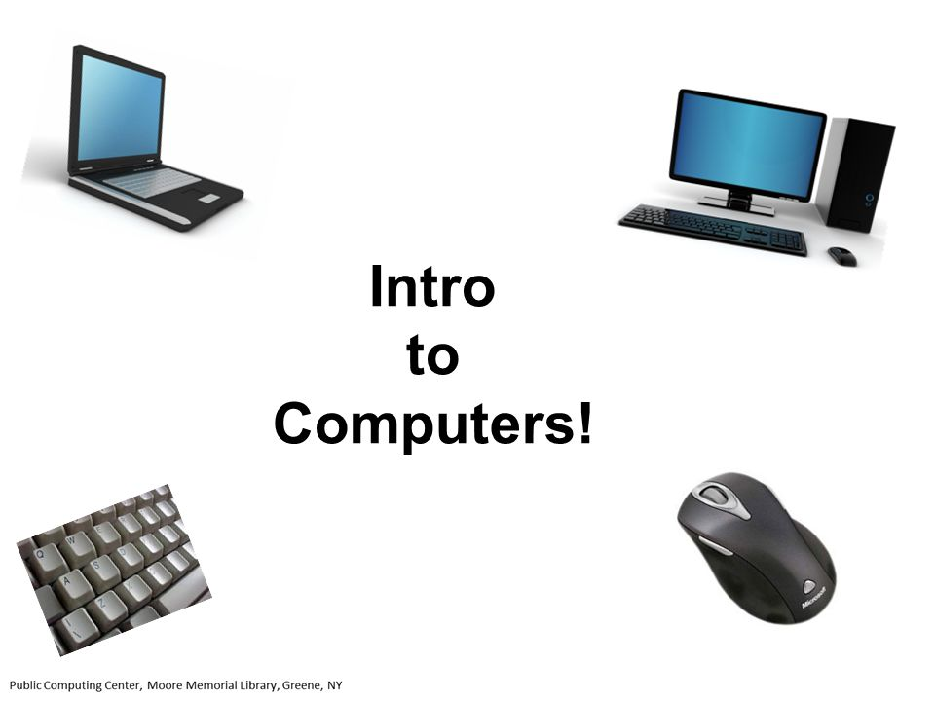

* **Life skills**

**We have basically been talking openly about life experiences and made vision boards that help us visualize the future we intend to have.**

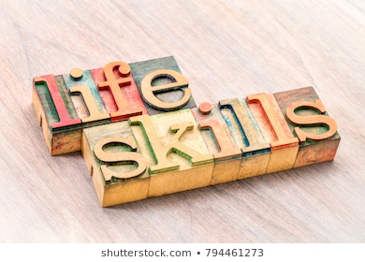

* **HTML\CSS**

**It’s a programming language that to me looks similar to python though a little easier.**

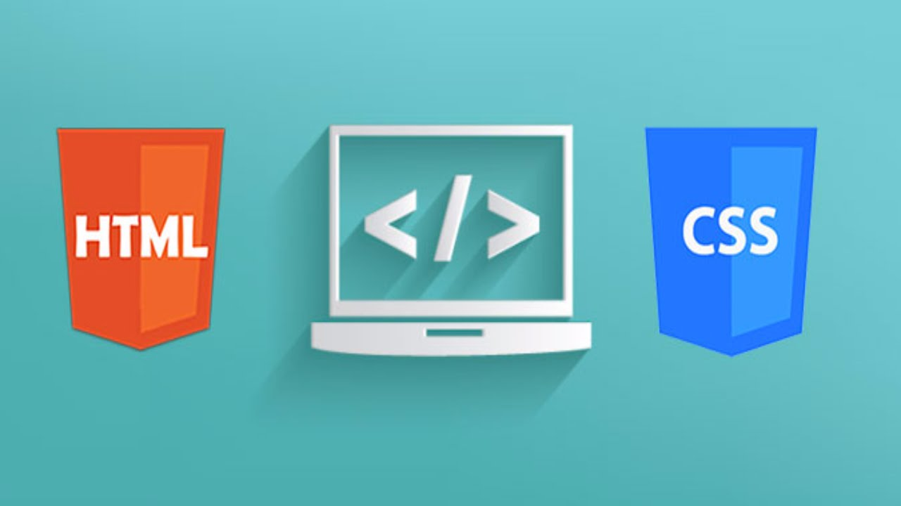

* **PYTHON**

**Also a programming language, though it is used majorly if not entirely on coding.**

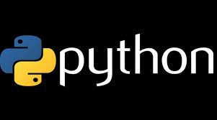

* **HARDWARE DESIGN**

**We have so far majorly tackled Design thinking.**

**It entails humans solving problems that emphasize on empathy, collaboration, co creation and stakeholder feedback to unlock creativity and innovation.**

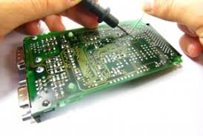

* **GRAPHIC DESIGNING**

**In the first lesson we learned how to draw pictures that can be used to describe how we feel literally.**

**There after we learned how to use adobe illustrator, where we majored on using a pen tool.**

**With this we learned how to draw cartoons using the pen tool itself**



* **MOBILE NETWORKING**

**We have had zero lessons on the unit because our Lecturer met an unfortunate accident.**

**We wish him\her quick recovery.**



* **ENTREPRENEURSHIP**

**We have expounded on people that discovered things like electiricty, the bulb, penicillin, the internet and others.**

**Different companies that major in IT have also been revised and their founders acknowledged.**

* **ELECTRONICS**

**We basically learnt about Kritchoff laws.**

* **Circuit**
* **Voltage**

**We also acquired knowledge on arranging cells parallel or in series form.**

